Installing python

1. search for 'python download' and click on the first link or open https://www.python.org/downloads/
2. Scroll down to the bottom and click on the windows installer (64/32 bit).
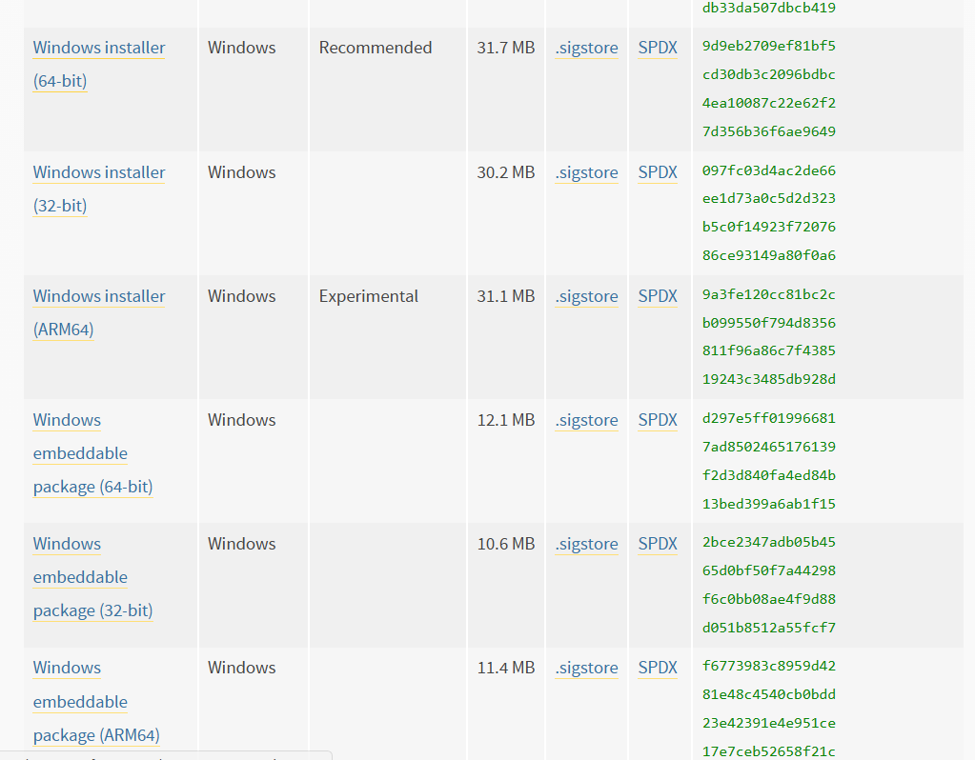

3. Click one the ‘add python to .exe to path’ and click customize installation.
